**1**

**|**

P a g e

**Roll # :**

Sp22-bse-073

**Assignment :**

Project

**Submitted to :**

Furqan Mehmood

**Date :**

5

/

2

7

/2023



**Name :**



Muhammad Shahzeb



**Question:- Difference between Static and Dynamic Modelling…?**

In software engineering, there are two primary methods used to comprehend and describe various system components: static modelling and dynamic modelling.

**Static Modelling:** Static Modelling is concerned with capturing the structure, arrangement, and connections between distinct system components. It is mostly focused on the system's static (i.e., non-evolving) features. Static models offer a snapshot of the system at a specific point in time and aid in comprehending the architecture, entities, properties, and relationships between them of the system.

The following static diagrams are frequently used in static modelling:

**Class Diagram**: Displays classes, along with their characteristics, methods, and relationships, to represent a system's static structure.

**Object Diagram**: Shows the actual objects and their associations, illustrating instances of classes and their relationships at a certain time.

**Package Diagram**: Shows how classes are organized into namespaces or packages, highlighting dependencies and connections between them.

**Component Diagram:** Shows how a system's physical and logical components interact with one another.

**Deployment Diagram**: Shows how software and hardware are related by showing how software components are physically deployed on hardware nodes.

**Dynamic modelling**: Dynamic modelling focuses on simulating how system components behave and interact over time. It records dynamic features such as occurrences, state changes, a series of deeds, and interactions between various system components.

**Use Case Diagram**: Demonstrates the functional needs and user interactions by illuminating the interactions between actors (users or external systems) and the system.

**Sequence Diagram**: Shows the sequence of messages sent and received as well as the order in which actions were taken to represent the interactions between objects in a system across time.

An activity diagram shows activities, decisions, and parallel or concurrent actions while describing the workflow or process flow within a system.

**State chart Diagram**: Represents an object's various states and how those states change in response to external factors like events or conditions.

**Collaboration Diagram**: Highlights structural links and message flows while illustrating the dynamic interactions between system elements.

Together, these diagrams give a complete picture of the system's static structure and dynamic behavior since they complement one another.

Question:- Diagrams for Online Shopping System.

**Use case diagram**

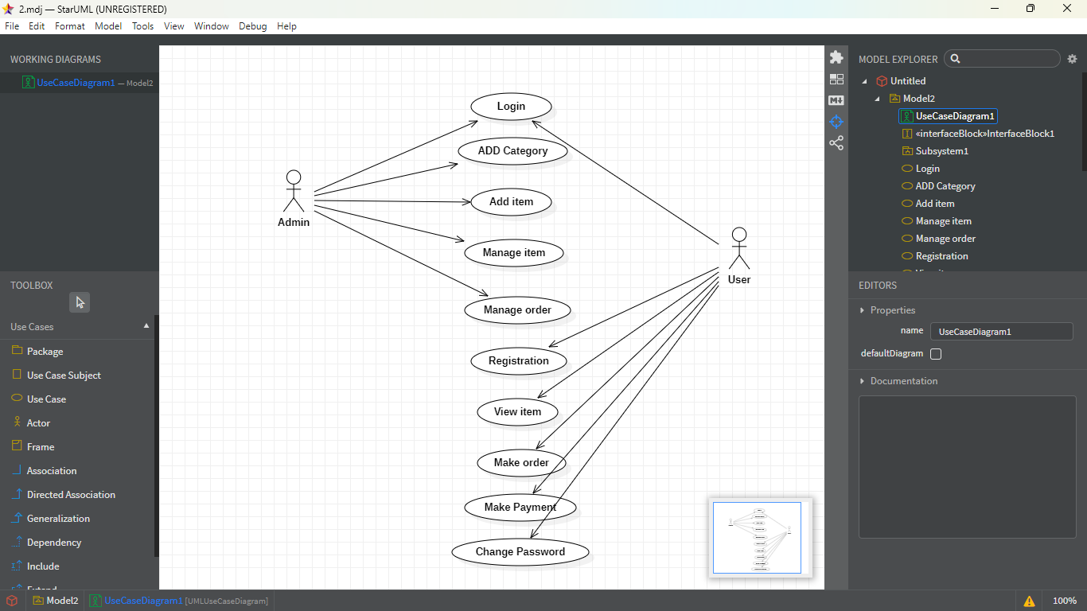

**Class diagram**

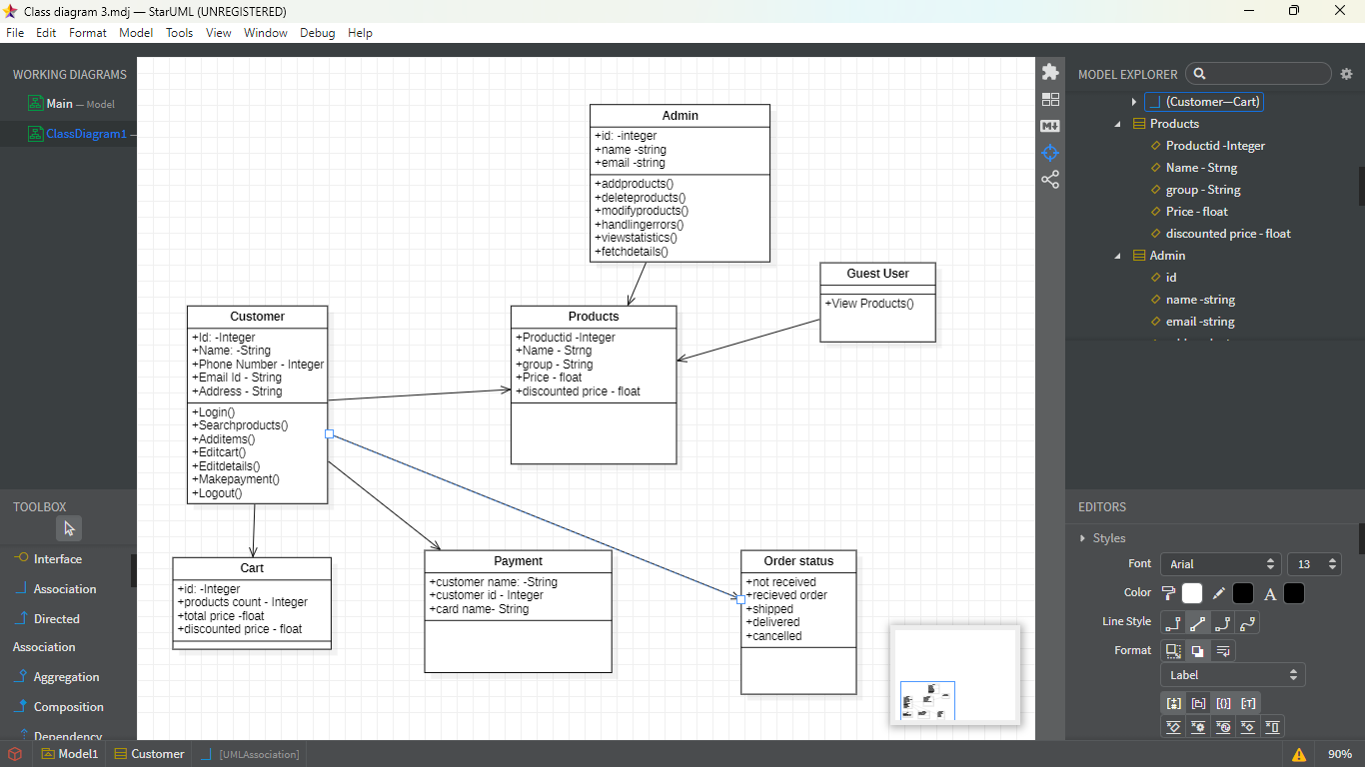

**Sequence diagram**

